1) Zero-Shot Prompting :
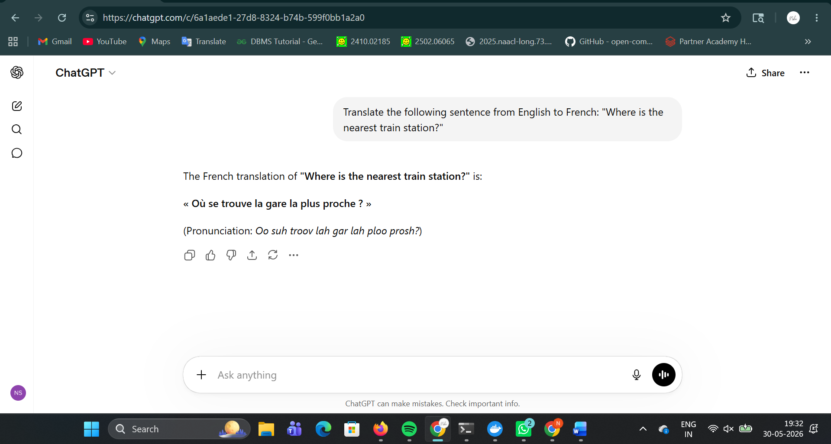

2) One-Shot Prompting :
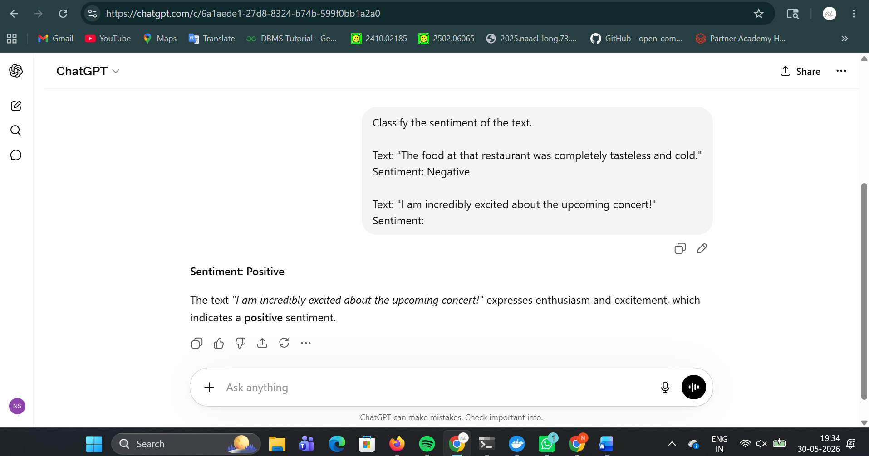

3) Few-Shot Prompting :
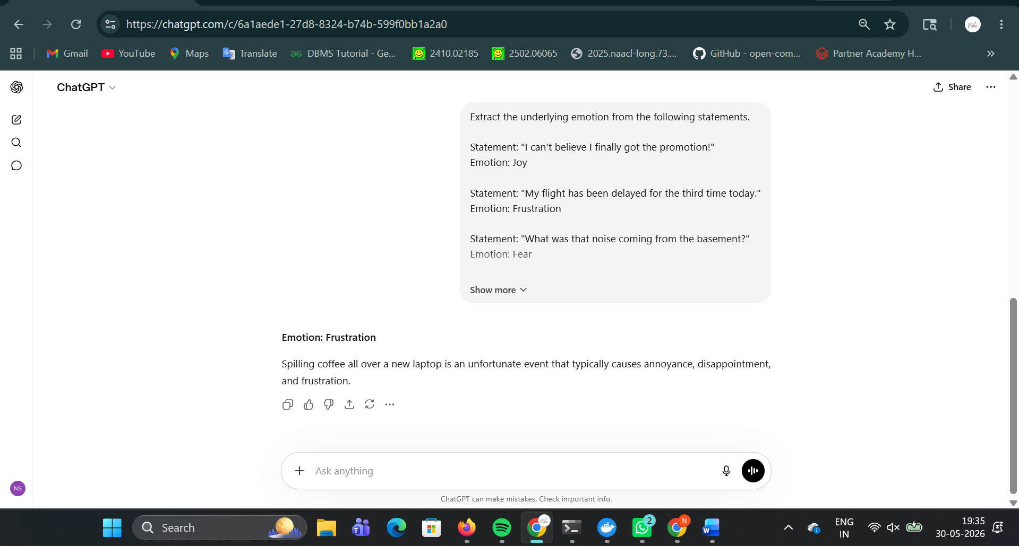

4) Role Prompting :
a) Weak Role based prompting:
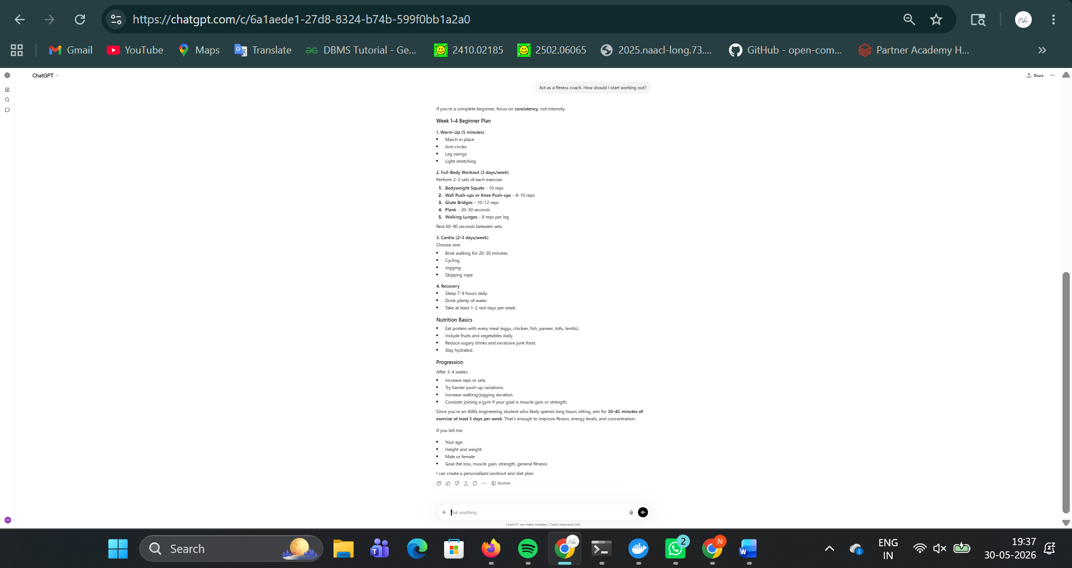

b) Strong Role based prompting:
